HeartWise Nutrition: A Young Leader’s Journey to Make Nutrition Inclusive in Bangladesh

Joya’s interest in nutrition began at home, around her family’s kitchen table where conversations often circled around food, safety and care. Her curiosity eventually led her to study Nutrition and Food Engineering, but her direction became clearer after she joined the Food Systems Youth Leadership Training supported by GAIN.

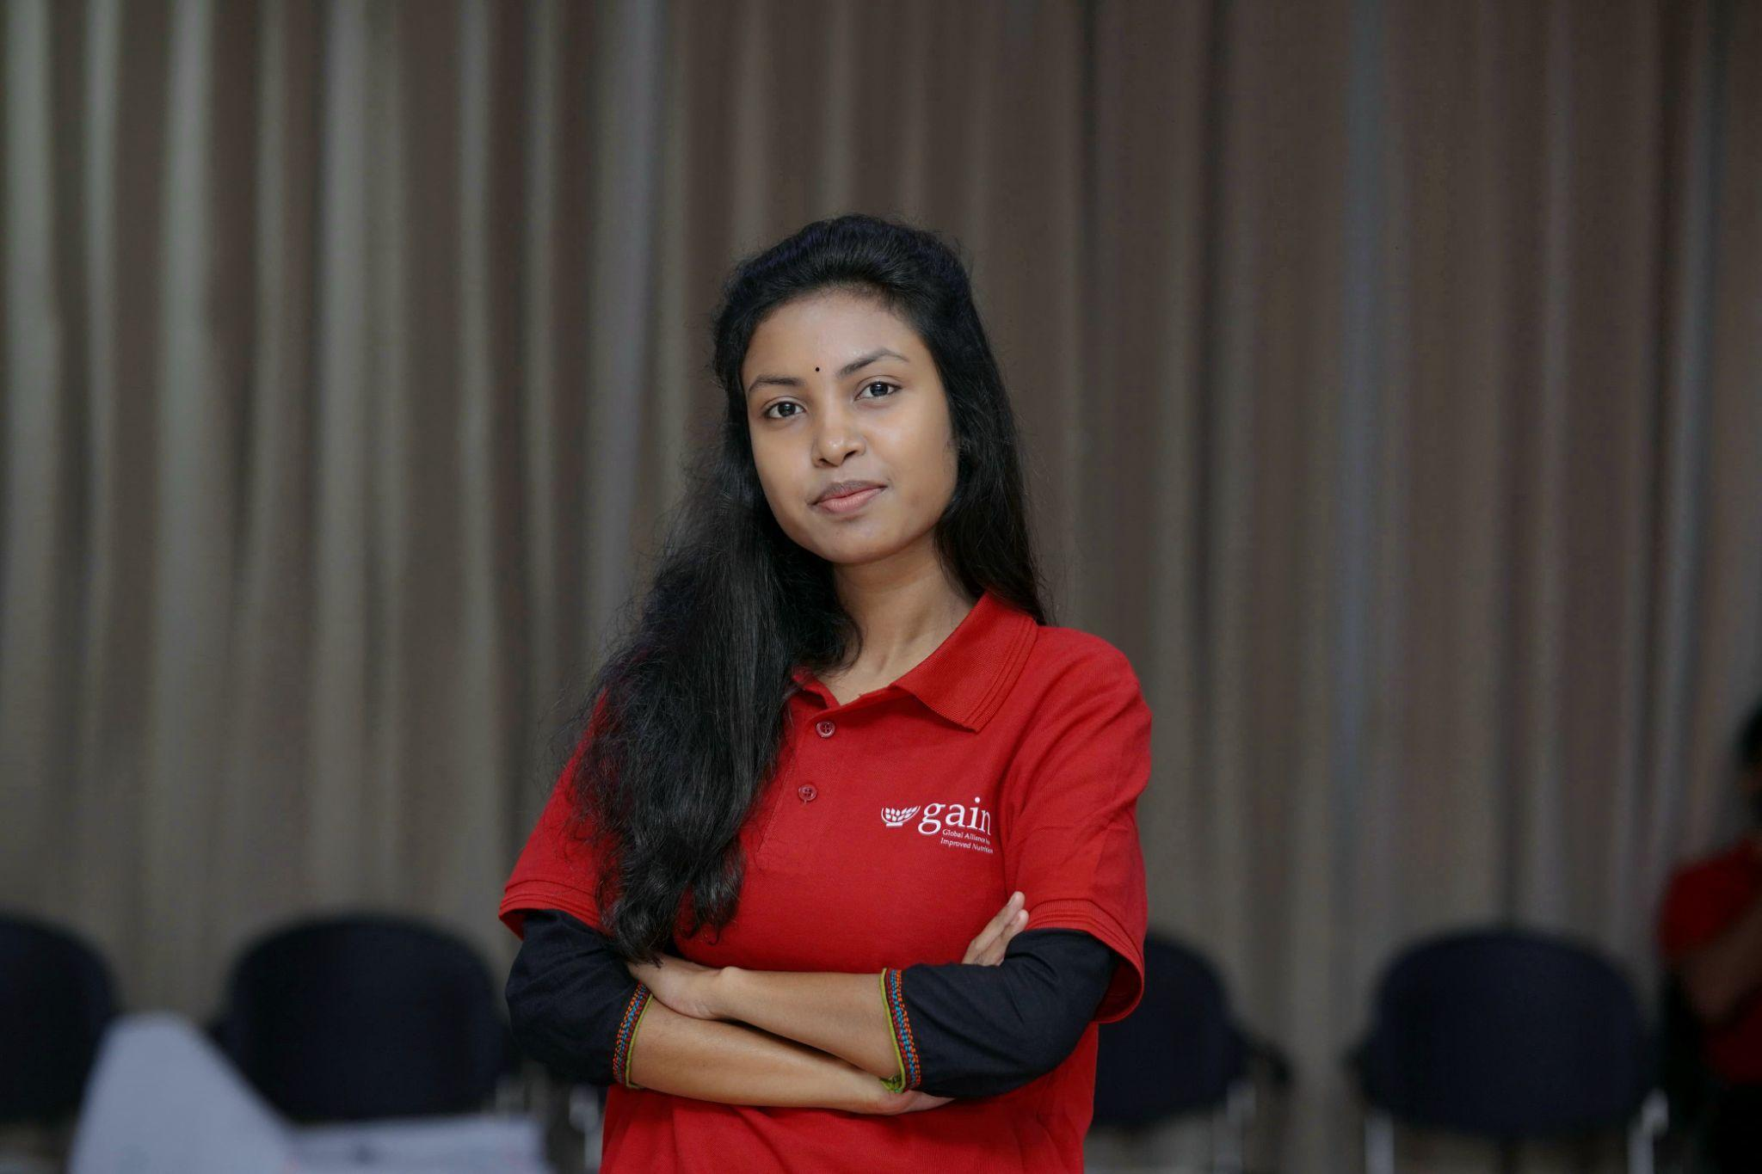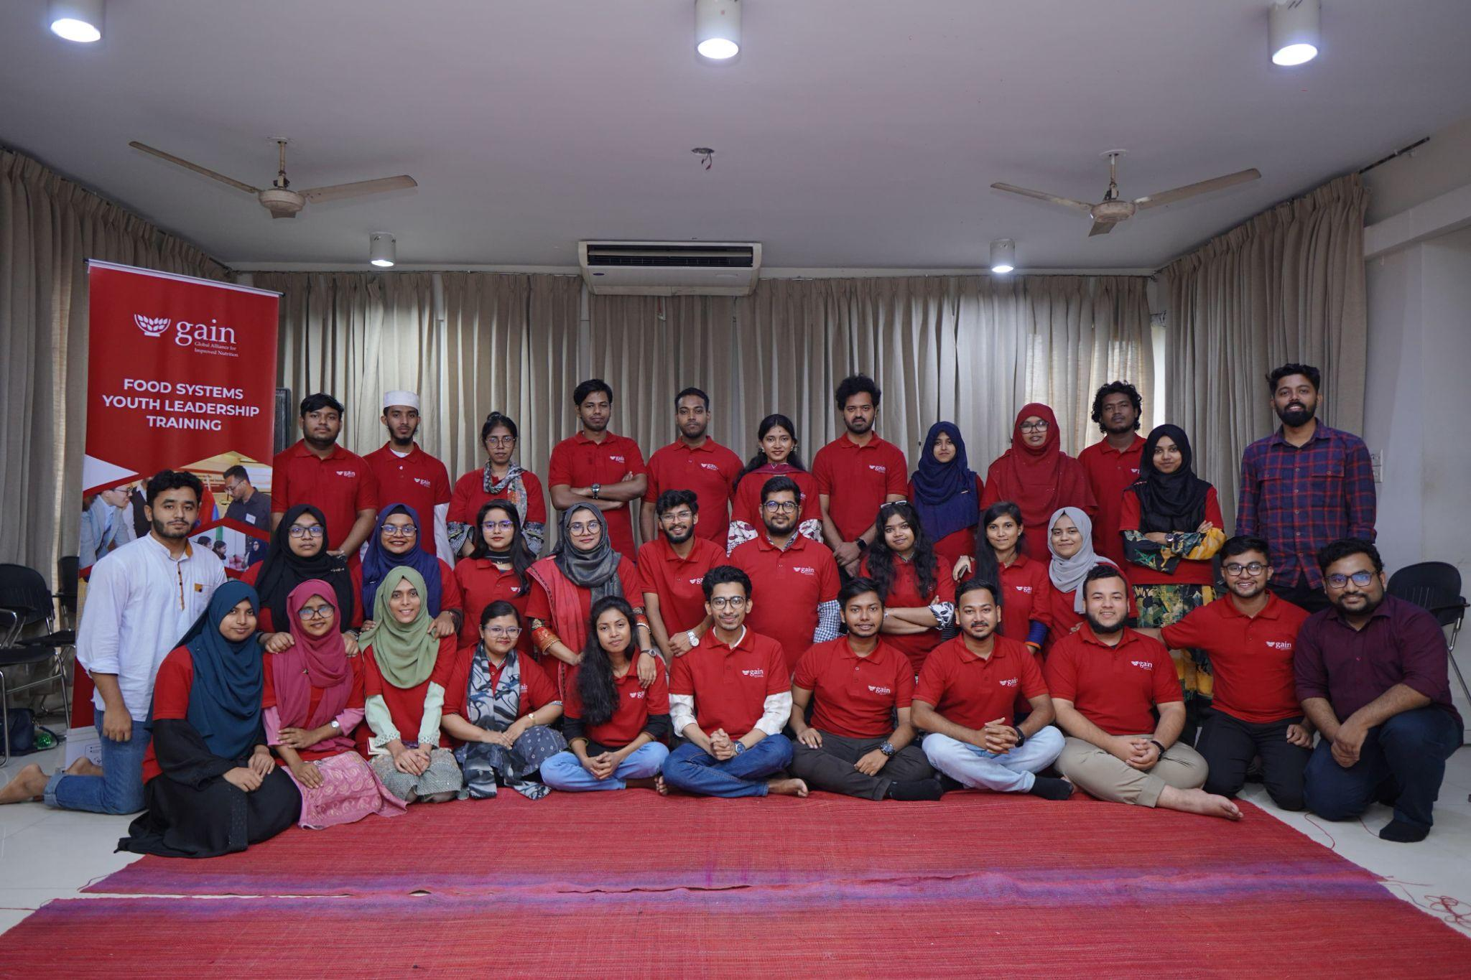

“Before the training, I focused on small, individual problems,” she said. “The training helped me see the bigger picture. It showed me how to look at root causes and think about long term change. It gave me confidence to imagine something larger for my community.”

This shift in perspective guided her back to a place she already knew well: Mirpur Buddhi Protibondhi and Autistic School. She had previously supported the children there, but now she saw the challenge differently. Many of the children avoided vegetables and struggled with basic hygiene, yet the issue was not simply about food choices. It was about how nutrition connected to their sensory needs, comfort and learning.

In September 2024, Joya created HeartWise Nutrition BD, a youth led platform built around what she calls a “HeartWise” approach. For her, HeartWise means combining nutrition knowledge with empathy, patience and an understanding of each person’s needs. She wanted nutrition education to feel friendly and inclusive, especially for children who often feel left out.

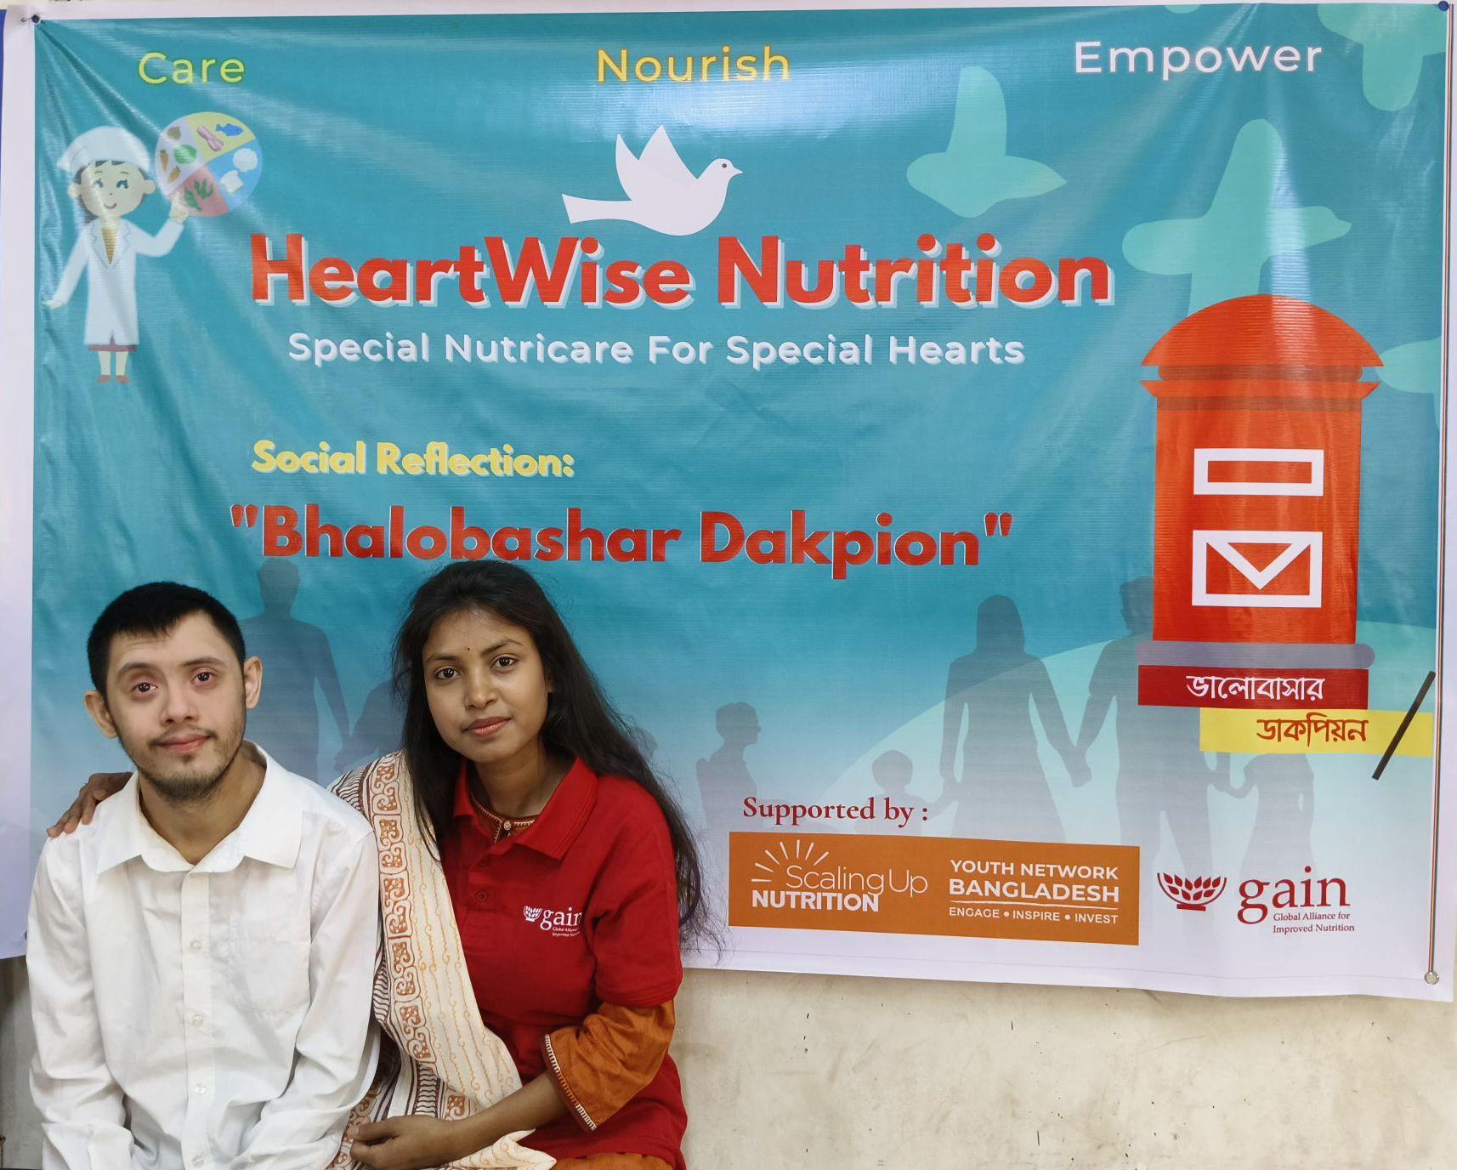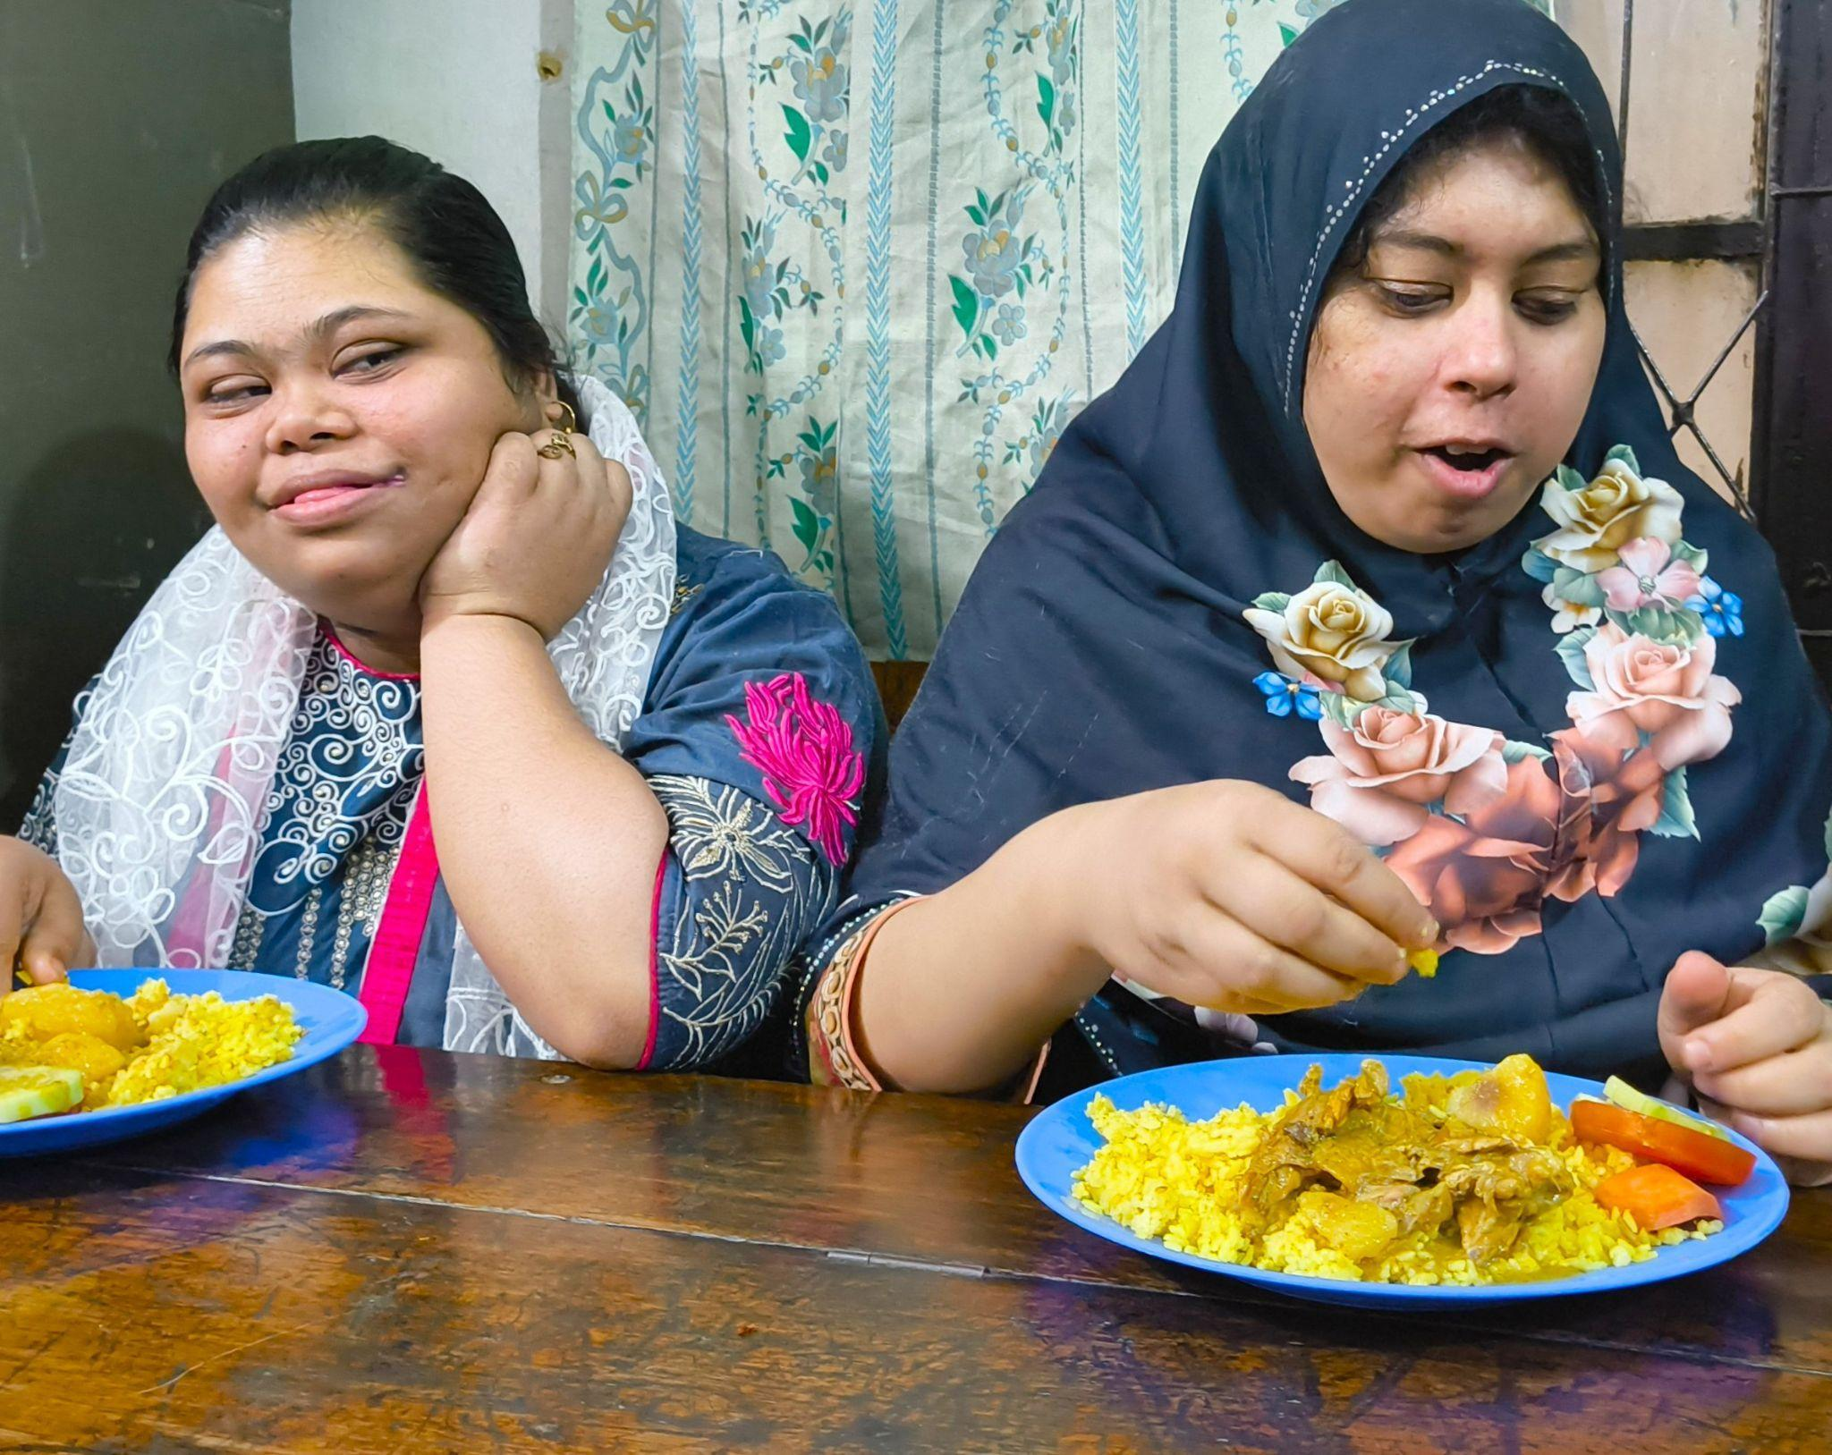

Her first activities began at the Mirpur school. Instead of instruction sheets or strict rules, she used games, drawings and storytelling to introduce new foods. Slowly, children began smiling during meal times, washing their hands more regularly and tasting fruits and vegetables they previously refused. “Seeing a child willingly try a carrot because we made it fun felt like a real achievement,” she said.

Her work continued to grow. In December she completed GAIN’s Training of Trainers programme, which helped her guide ninety new youth leaders across three districts to begin their own community activities.

In February 2025, HeartWise launched a Midday Meal Program for neurodivergent children. To reach families who often face greater barriers, she organized the Pushti Bondhu Camp, a full day programme for sixty children with disabilities and their caregivers. The children received BMI checks, dietary consultations and health screenings. Parents joined open discussions on caregiving and nutrition. The initiative was supported by GAIN, SUN Youth Network Bangladesh, Pustibid Foundation, SERAC Bangladesh, Youth Against Hunger and JCI Dhaka Diplomats.

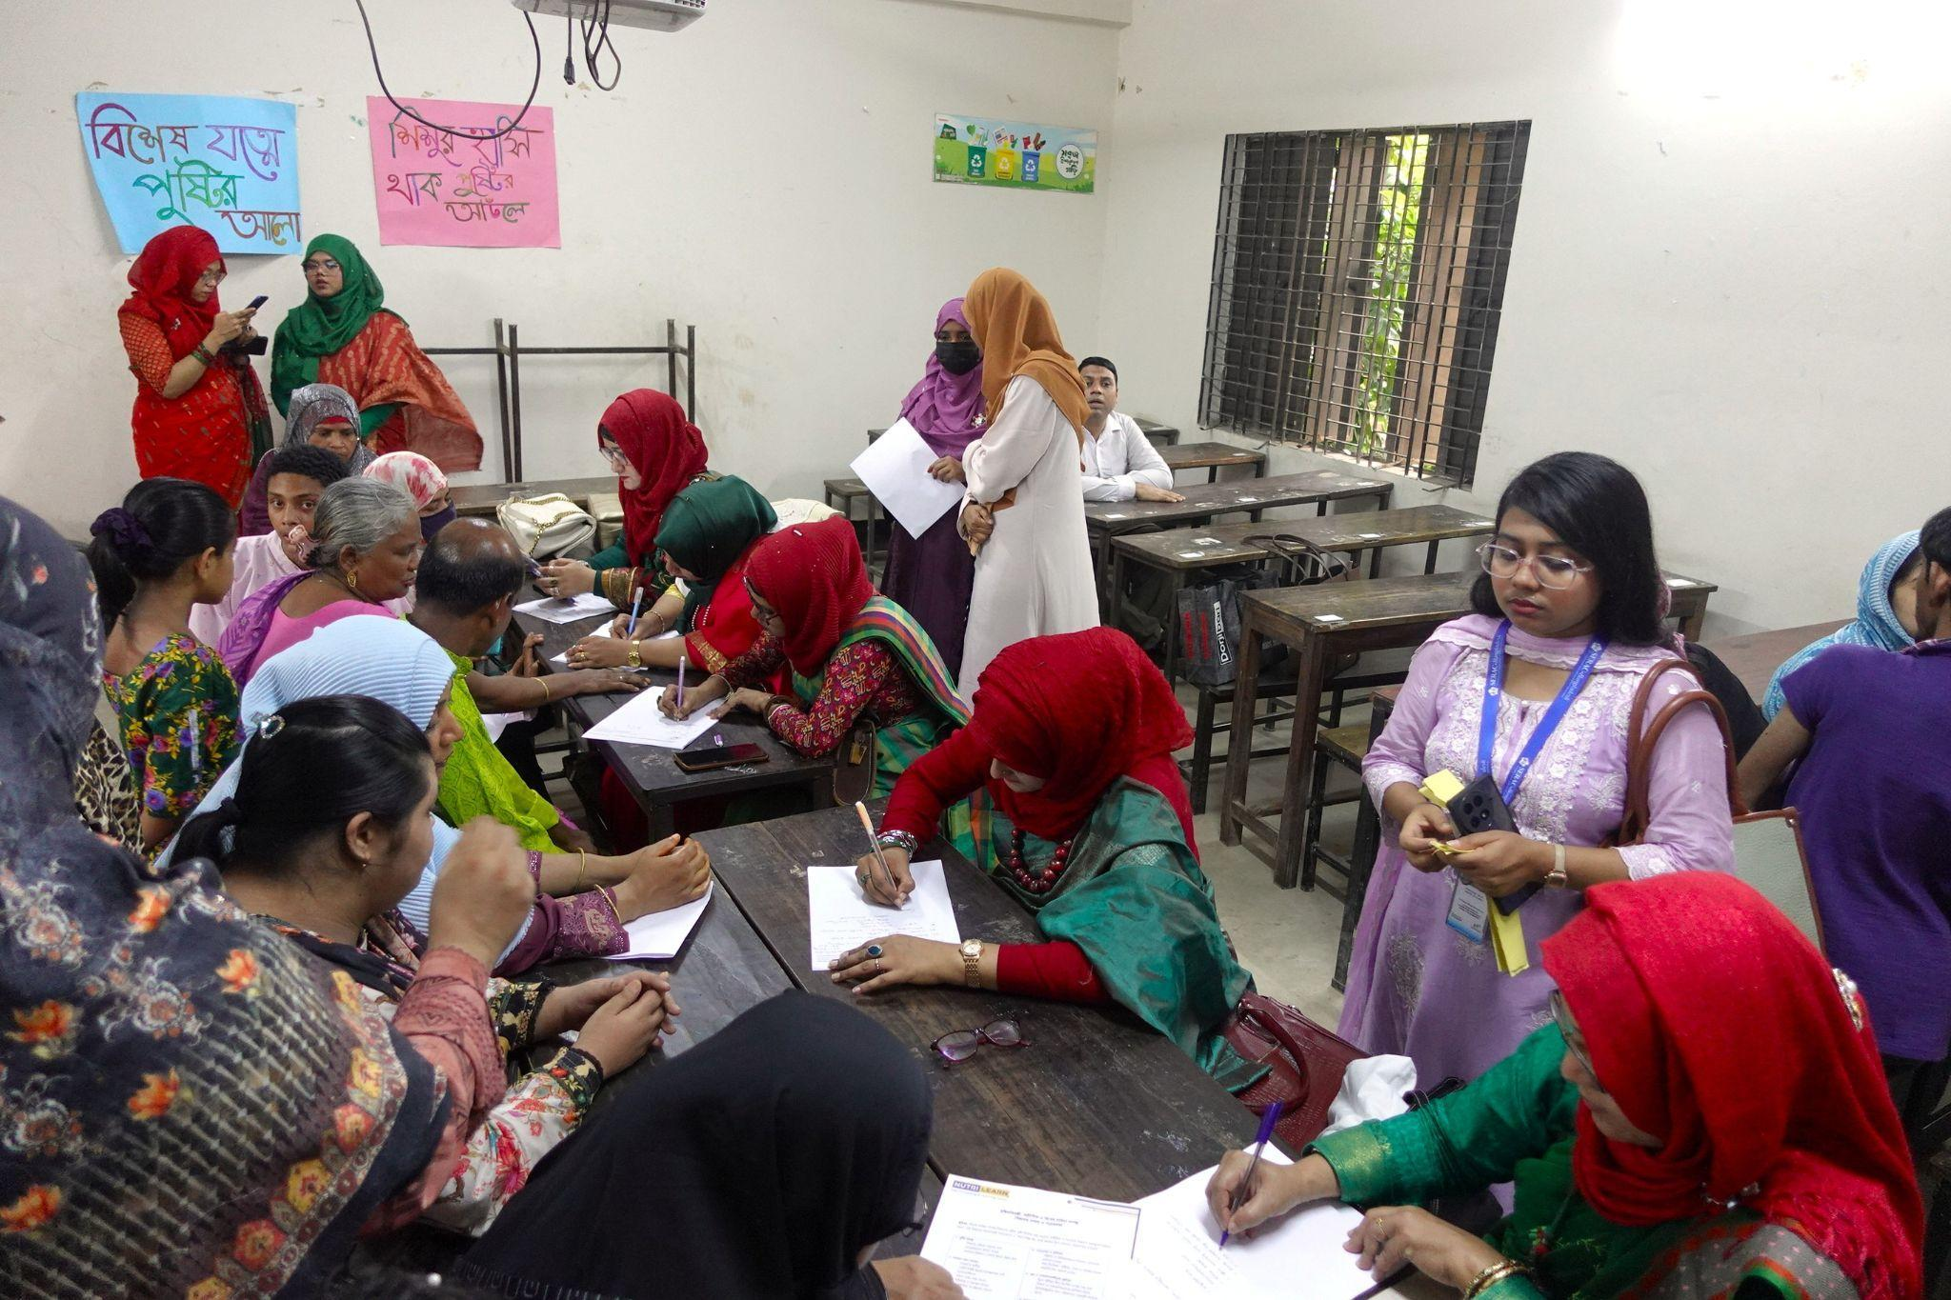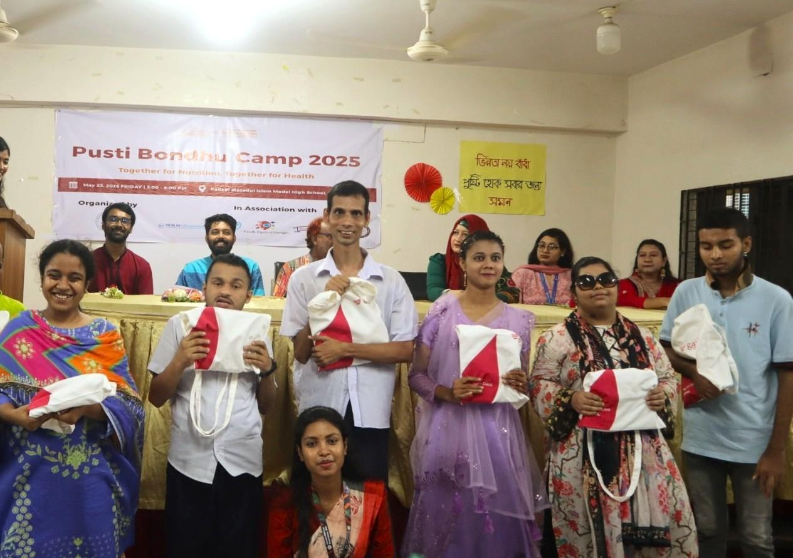

The impact has been appreciated by the community. Masud Laskar, Principal of Mirpur School for the Intellectually Disabled and Autistic Children, said, “Initiatives like the Pushti Bondhu Camp are strong examples of inclusive community engagement. Through personalized counseling, these programs help us understand the unique nutritional needs of our children and remind us of the care they deserve.”
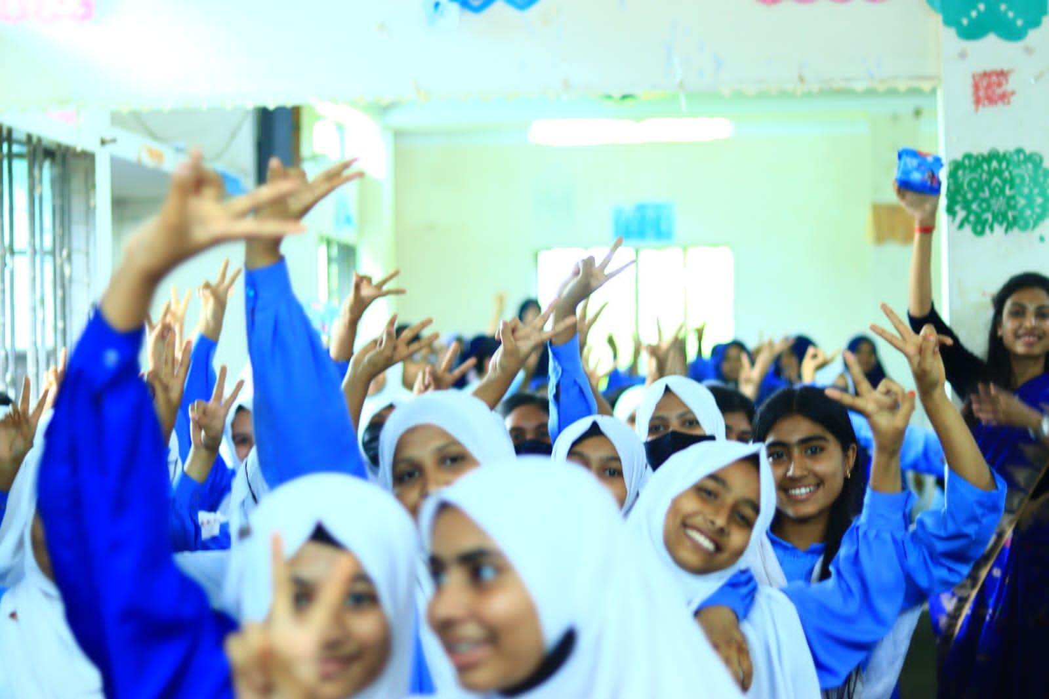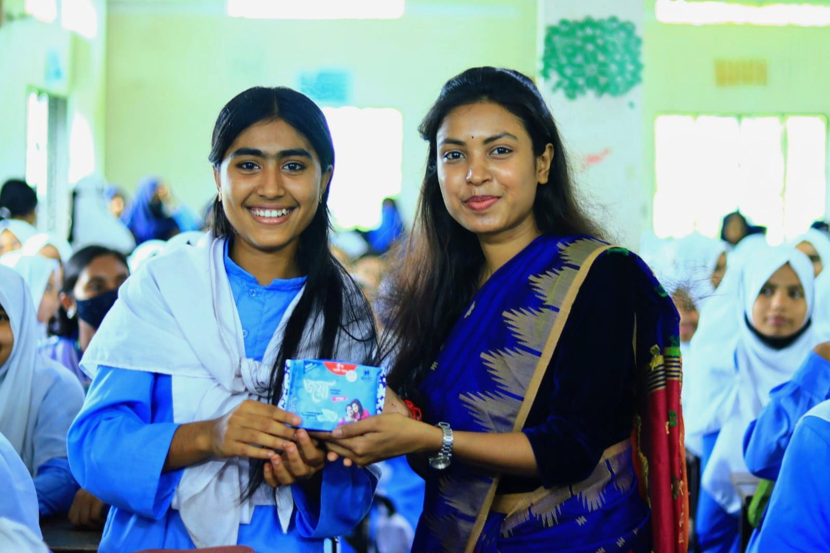
Joya’s own adolescent years also shaped her work. Topics like menstruation and physical changes were rarely discussed, leaving many girls unprepared. Some skipped meals, missed classes or felt ashamed of natural changes. These memories inspired her to create Kishori Kothon, a programme that helps adolescent girls learn about nutrition, menstruation, hydration and emotional wellbeing. With support from the SMC School Activation Program, Joya held Kishori Kothon sessions in six schools in Shayestaganj. Girls sat together, talked openly and received accurate guidance. A total of 672 sanitary pads were also distributed, addressing a basic but often neglected need.
Mohammad Abdullah Al Mamun, Principal of Zohur Chan Bibi Women’s College, commented, “Awareness activities like Kishori Kothon are timely and important. Through regular nutrition and health education, our girls can become healthier, more confident and better prepared for the future. These efforts should be expanded across the country.”
Today, HeartWise Nutrition BD consists of sixteen young people working side by side to make nutrition education inclusive, compassionate and accessible. For Joya, the idea remains simple. Nutrition is not only about food. It is also about understanding, respect and giving people the support they need to live healthier lives.

